# Week 4 QUIZ - Diving deeper into relationships

## Question 1

Parte superior do formulário

**The following statements refer to this plot of the rate of Infant mortality and the average number of children per woman for countries around the world subset by Leap.Year. Colour has been used to identify the different regions each country belongs to.**

[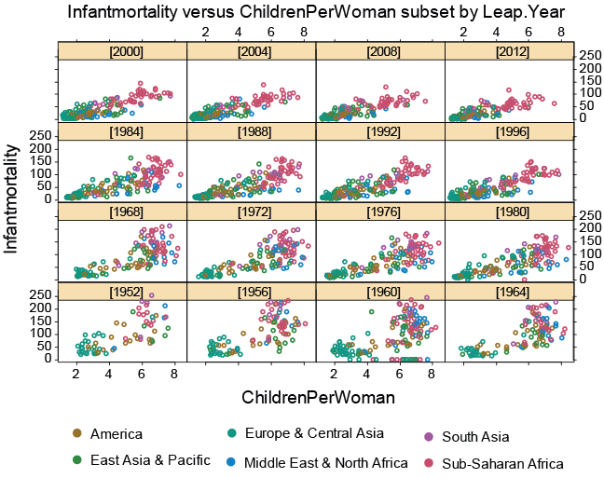Enlarge image](https://flexiblelearning.auckland.ac.nz/data-to-insight/4/2/images/graph9-big.png)

Which one of the following statements is **FALSE**?

**This tiled plot explores three different variables.**

Over time there is a trend towards lower infant mortality.

In recent years, the relationship between **InfantMortality** and **ChildrenPerWoman** has become stronger.

Over time there has been an increasing separation between the countries in the South Asia and Sub-Saharan Africa regions (pink and purple) and countries of other regions (blue, green and brown).

There is a positive relationship between **ChildrenPerWoman** and **InfantMortality**.

**Correct**

This statement is **FALSE** – we are representing four different variables: **InfantMortality** and **ChildrenPerWoman** on the axes, **Region** using colour, and **Leap.Year** using subsetting.

## Question 2

Parte superior do formulário

**The following statements refer to this plot of the rate of infant mortality and the average number of children per woman for countries around the world.**

The large green circle is China and the large pink circle is India. The third largest symbol (brown) is the United States of America.

[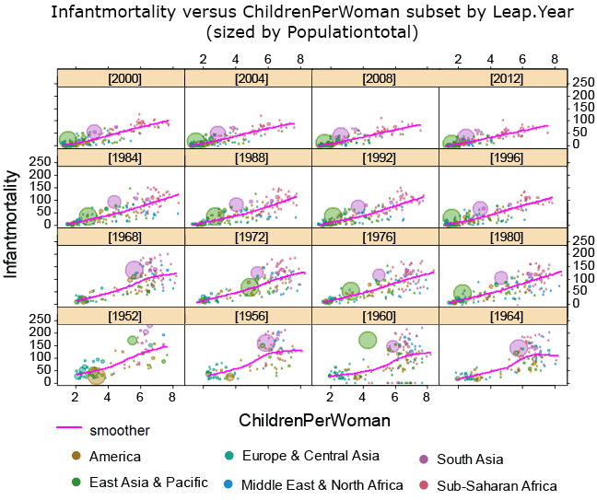](https://flexiblelearning.auckland.ac.nz/data-to-insight/4/2/images/graph10-big.png)

Which one of the following statements is **FALSE**?

Sizing the symbols according to population total emphasises the countries with larger populations.

China had a high infant mortality rate in 1960, but from 2000 it has had a very low rate of infant mortality and very low number of children per woman.

**India has always had a slightly higher number of children per woman and Infant mortality rate than China. (Ignore 1952, 1956 and 1964 where one or both had missing data.)**

Over time, the trend has become flatter and straighter.

**Correct**

This statement is **FALSE** – In 1960 China had a higher rate of infant mortality than India.

Parte inferior do formulário